Top 3 Marketing Channels by Revenue-;
This query quickly pulls your top 3 performing acquisition channels based on total generated revenue, calculating the conversion counts and Total Revenue by individual channel.

QUERY-;

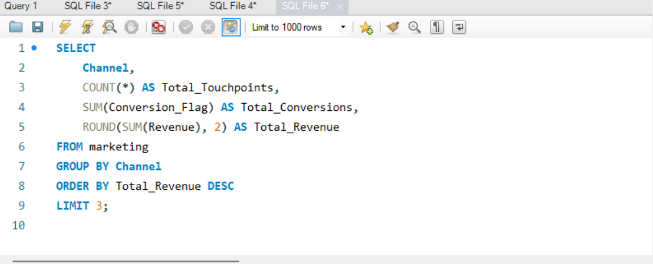

OUTPUT-;

